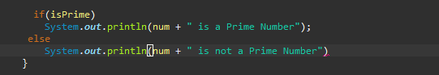

For this error I made I forgot to add the semicolon to end the statement

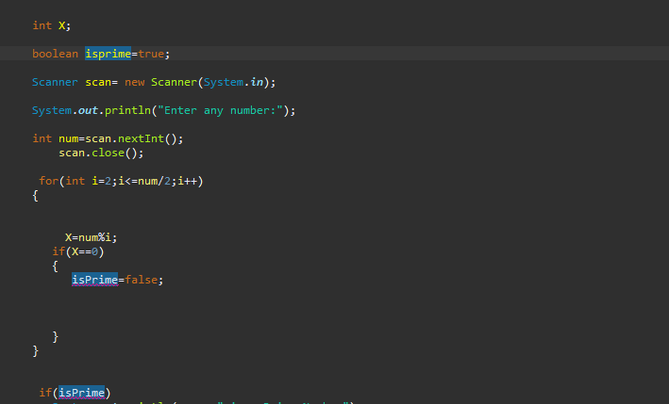

A syntax error has been made in the code where the beginning is lowercase prime and the second and third on is capitalized.